This document will instruct you on how to setup an XAMPP web server as well as the MariaDB for use in Selenium testing.

**XAMPP Installation Instructions**

Navigate to the following [location](https://www.apachefriends.org/index.html) and select the appropriate download for your computer.

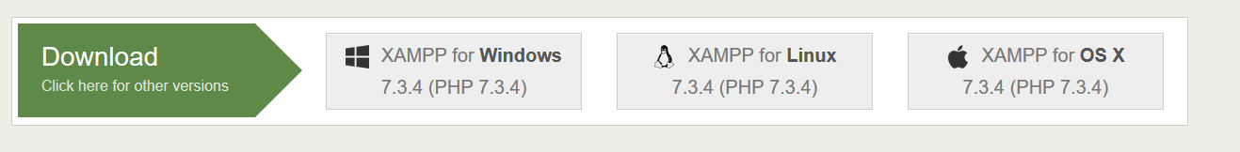

Proceed with the installation of XAMPP by clicking on the executable that gets downloaded.

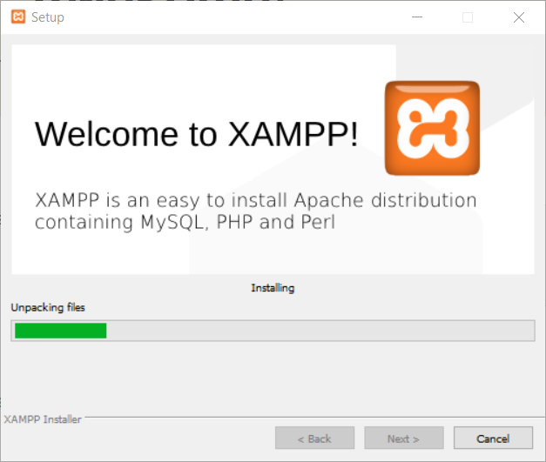

After the installation (and saying “Yes” to starting the Control Panel, and after selecting your language), you should see the following XAMPP Control Panel:

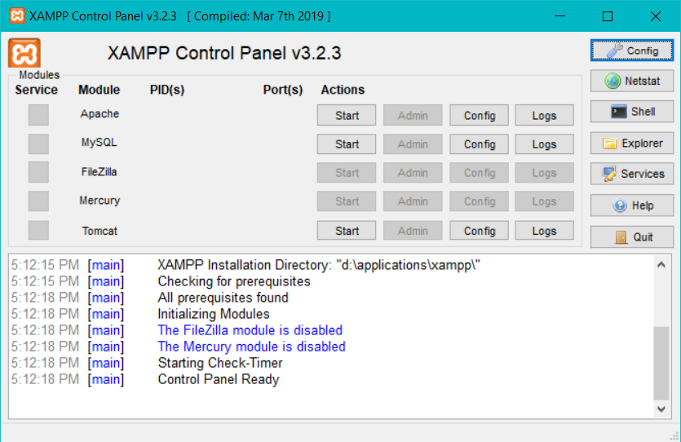

To start the Apache WebServer, click on the Start button beside Apache.

You should now see something like the following to indicate that Apache has been successfully started:

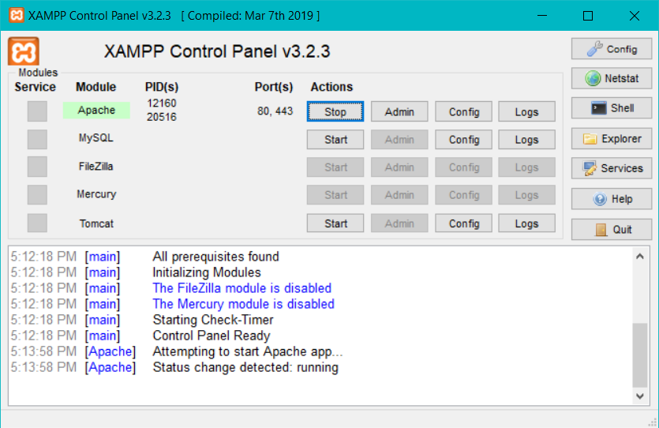

The main directory for all web documents is **\xampp\htdocs**. If you put a file "prog8440test.html" in this directory, you can access it with the URI "http://localhost/prog8440test.html". Along with the instructions, you should find the prog8440test.html file – go ahead and place this file in your \xampp\htdocs folder. Now, from your browser, access [http://localhost/prog8440test.html](http://localhost/SENG8040Test.html) you should see the following screen…

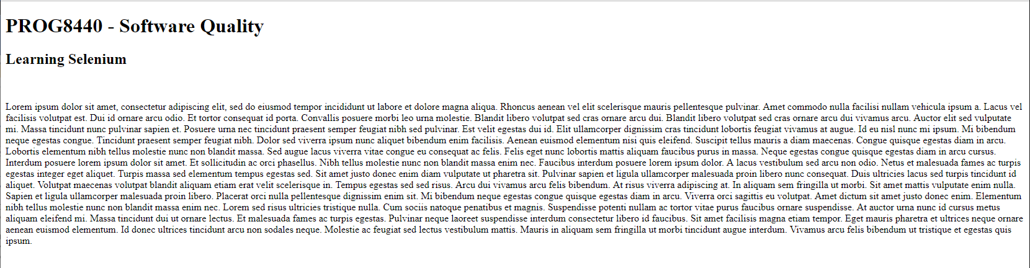

This will confirm that your Apache Web Server is functional! Good work 😊